*Florida International University*

*School of Computing and Information Sciences*

CIS 4911 - Senior Capstone Project

Software Engineering Focus

Feature Document

User Story #**855**

**Team Member:**

Jorge Nonell. Eric Aguiar, Alex Karpis, Chris Naranjo

**Product Owner(s)**:

Francisco Ortega

**Mentor(s)**:

Francisco Ortega

**Instructor**: Masoud Sadjadi

**User Story** [**#8**](https://fiu-scis-seniorproject.mingle.thoughtworks.com/projects/multi_modal_interactive_paint/cards/848)**55** Work with Alex to get Kinect speech integrated

### Description:

* As a user I would like to speak to the application and have it respond to my commands so that it can make interacting with the drawing program easier or more accessible. This will also make the kinect more usable since the user usually has to stand so far away from it.

### Acceptance Criteria:

1. When I speak the following commands to the kinect it respond accordingly
   1. Name of a supported shape (i.e. circle, rectangle, triangle, etc) it changes the current shape I am drawing
   2. Name of supported color (i.e. red, green, etc) it changes the color I am currently painting with.
   3. “Fill shapes” it makes the subsequent shapes I draw filled if they are currently not
   4. “Unfill shapes” it makes the subsequent shapes i draw not filled if they currently are
   5. ”Undo” it undoes the last drawing done
   6. “Symmetry” will turn on the symmetry line if it is off, or turn it off if it is on.

**Use Case** [**#8**](https://fiu-scis-seniorproject.mingle.thoughtworks.com/projects/multi_modal_interactive_paint/cards/848)**55 Kinect Speech Recognition**

Use Case:

A user should be able to give the kinect voice commands and our application should correctly interpret the speech and change the state of the application.

Details:

Actor: user

Pre-conditions:

* Project working on VS2015
* Kinect is connected

Description:

* When the user gives voice commands, the application should respond.

Decision Support:

Frequency: Often. Users are far away from kinect making this an easier way to change the mode the application is currently running in.

Criticality: High. Enables user to more efficiently interact with the application

Risk:Low. Users do not currently rely on this feature

Constraints:

Reliability: Very Reliable.

Performance: There may need to be performance improvements

Supportability:

Must work with ACER Multitouch, Leap, RealSense and Eyex

Modification History:

Owner: Jorge Nonell

Initiation date: 07/5/2016

Date last modified: 07/5/2016

**Use Case Diagram**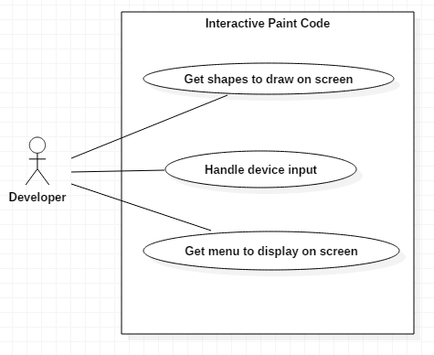

**Sequence Diagram**

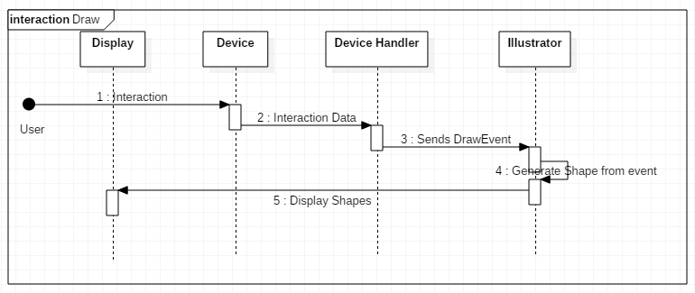

**Class Diagram**

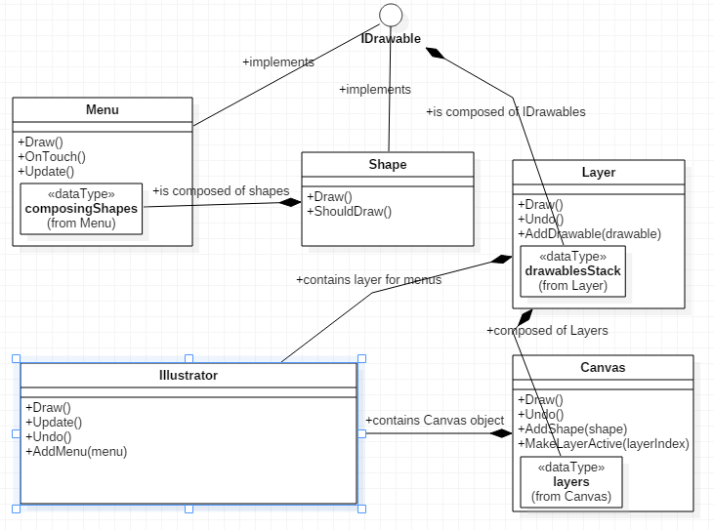

**Unit Test**

Sunny Day Tests

Test Case 1: Devices Still Work

Test Purpose: Ensure that user can still use the devices to draw on screen after the window is resized

Test Setup:

⦁ run program

Test Output:

Every line drawn correctly

Expected Output:

After testing all integrated devices, i.e. the RealSense, Leap and Eyex can still contribute to drawing, the screen should draw correctly

Test Case 2: Window is responsive

Test Purpose: Ensure that user can expand the window and have the menus and touch points scale to size.

Test Setup:

⦁ run program

Test Output:

Any shape can be drawn correctly anywhere on the screen and the menus resize according to the size of the window. Works but there is a memory issue with the menus, which causes pixel fragmentation.

Expected Output:

After testing all integrated devices, i.e. the RealSense, Leap and Eyex can still contribute to drawing anywhere on the screen correctly. The menus are responsive to the screen size.

**Integration Test**

Devices can still be used to draw in the application, i.e. the RealSense, Leap and Eyex can still contribute to drawing. The menus are responsive to the screen size.